|  |  |
| --- | --- |
| Activity | **Data Type** |
| Number of beatings from Wife | **Discrete** |
| Results of rolling a dice | **Discrete** |
| Weight of a person | **Continuous** |
| Weight of Gold | **Continuous** |
| Distance between two places | **Continuous** |
| Length of a leaf | **Continuous** |
| Dog's weight | **Continuous** |
| Blue Color | **Categorical** |
| Number of kids | **Discrete** |
| Number of tickets in Indian railways | **Discrete** |
| Number of times married | **Discrete** |
| Gender (Male or Female) | **Categorical** |
|  |  |

Q1) Identify the Data type for the Following:

Q2) Identify the Data types, which were among the following

Nominal, Ordinal, Interval, Ratio.

|  |  |
| --- | --- |
| Data | Data Type |
| Gender | Nominal |
| High School Class Ranking | Ratio |
| Celsius Temperature | Interval |
| Weight | Ratio |
| Hair Color | Nominal |
| Socioeconomic Status | Ordinal |
| Fahrenheit Temperature | Interval |
| Height | Ratio |
| Type of living accommodation | Ordinal |
| Level of Agreement | Interval |
| IQ(Intelligence Scale) | Ratio |
| Sales Figures | Interval |
| Blood Group | Ordinal |
| Time Of Day | Ratio |
| Time on a Clock with Hands | Ratio |
| Number of Children | Ratio |
| Religious Preference | Ordinal |
| Barometer Pressure | Ratio |
| SAT Scores | Ratio |
| Years of Education | Ratio |
|  |  |

Q3) Three Coins are tossed, find the probability that two heads and one tail are obtained? ANS: 3/8

Q4) Two Dice are rolled, find the probability that sum is

1. Equal to 1 ANS: NOT POSSIBLE
2. Less than or equal to 4 ANS: 5/36
3. Sum is divisible by 2 and 3 ANS: 6/36

Q5) A bag contains 2 red, 3 green and 2 blue balls. Two balls are drawn at random. What is the probability that none of the balls drawn is blue?

ANS: 10/21

Q6) Calculate the Expected number of candies for a randomly selected child

Below are the probabilities of count of candies for children (ignoring the nature of the child-Generalized view)

|  |  |  |
| --- | --- | --- |
| CHILD | Candies count | Probability |
| A | 1 | 0.015 |
| B | 4 | 0.20 |
| C | 3 | 0.65 |
| D | 5 | 0.005 |
| E | 6 | 0.01 |
| F | 2 | 0.120 |

Child A – probability of having 1 candy = 0.015.

Child B – probability of having 4 candies = 0.20

Q7) Calculate Mean, Median, Mode, Variance, Standard Deviation, Range & comment about the values / draw inferences, for the given dataset

* For Points,Score,Weigh>Find Mean, Median, Mode, Variance, Standard Deviation, and Range and also Comment about the values/ Draw some
* inferences.

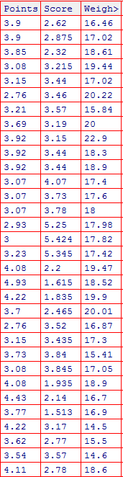

**Points**

**{**

**Mean = 3.5965625**

**Median = 3.5950000000000003**

**Mode = 3.07,3.92**

**Variance = 0.2858813508064516**

**Standard Deviation = 0.5346787360709715**

**Range = 2.17**

**}**

**Score**

**{**

**Mean = 3.21725**

**Median = 3.325**

**Mode = 3.44**

**Variance = 0.9573789677419355**

**Standard Deviation = 0.9784574429896967**

**Range = 3.911**

**}**

**Weight**

**{**

**Mean = 17.84875**

**Median = 17.71**

**Mode = 17.02,18.9**

**Variance = 3.1931661290322575**

**Standard Deviation = 1.786943236096843**

**Range = 8.4**

**}**

Q8) Calculate Expected Value for the problem below

1. The weights (X) of patients at a clinic (in pounds), are

108, 110, 123, 134, 135, 145, 167, 187, 199

Assume one of the patients is chosen at random. What is the Expected Value of the Weight of that patient?

ANS : 145.33

**Q9) Calculate Skewness, Kurtosis & draw inferences on the following data**

**Cars speed and distance**

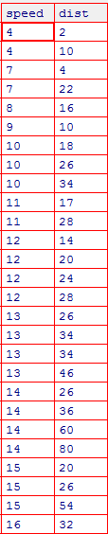

**The values of Speed:**

**Skewness: -0.895425 || Kurtosis: 0.249561**

**Negative Skewness and Positive Kurtosis.**

**The Values of Dist:**

**Skewness: 1.315141 || Kurtosis: 2.408227**

**Positive Skewness and Positive Kurtosis**

**SP and Weight(WT)**

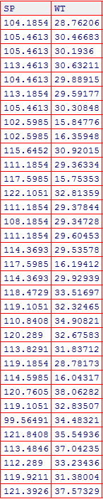

**The values of SP:**

**Skewness: -0.595445 || Kurtosis: -0.486607**

**Negative Skewness and Negative Kurtosis**

**The Values of WT:**

**Skewness: -1.347555 || Kurtosis: 1.152953**

**Negative Skewness and Positive Kurtosis**

**Q10) Draw inferences about the following boxplot & histogram**



**The above graph shows Positive Skewness.**



**The above box plot shows lot of outliers are present**

**Q11)** Suppose we want to estimate the average weight of an adult male in Mexico. We draw a random sample of 2,000 men from a population of 3,000,000 men and weigh them. We find that the average person in our sample weighs 200 pounds, and the standard deviation of the sample is 30 pounds. Calculate 94%,98%,96% confidence interval ?

**For 94% Confidence Interval = (199.4405, 200.5594)**

**For 98% Confidence Interval = (199.4373, 200.5627)**

**For 96% Confidence Interval = (199.4389, 200.5611)**

**Q12)** Below are the scores obtained by a student in tests

**34,36,36,38,38,39,39,40,40,41,41,41,41,42,42,45,49,56**

1. Find mean, median, variance, standard deviation.

**Mean: 41**

**Median: 40.5**

**Variance: 25.529411764705884**

**Standard Deviation: 5.05266382858645**

1. What can we say about the student marks?

**The Mean and Median shows the values are pretty close to each other meaning the average and center most value are almost same.**

**By Variance and standard Deviation We can state that the spread of data is on the higher side.**

Q13) What is the nature of skewness when mean, median of data are equal?

**Normal Skewness**

Q14) What is the nature of skewness when mean > median ?

**Positive Skewness**

Q15) What is the nature of skewness when median > mean?

**Negative Skewness**

Q16) What does positive kurtosis value indicates for a data ?

**Data not widely spread**

Q17) What does negative kurtosis value indicates for a data?

**Data is widely spread**

Q18) Answer the below questions using the below boxplot visualization.



What can we say about the distribution of the data?

**The data has more points before its mean value and less points after the mean values.**

What is nature of skewness of the data?

**The data shows Negative Skewness.**

What will be the IQR of the data (approximately)?

Q19) Comment on the below Boxplot visualizations?



Draw an Inference from the distribution of data for Boxplot 1 with respect Boxplot 2.

**Both Box Plots have same mean.**

**Box Plot 1 has less data set values than Box Plot 2.**

Q 20) Calculate probability from the given dataset for the below cases

Data _set: Cars.csv

Calculate the probability of MPG of Cars for the below cases.

MPG <- Cars$MPG

* 1. P(MPG>38)

**0.40741**

* 1. P(MPG<40)

**0.7531**

c. P (20<MPG<50)

**0.851852**

Q 21) Check whether the data follows normal distribution

1. Check whether the MPG of Cars follows Normal Distribution

Dataset: Cars.csv

**YES It doesn’t follows Normal distribution**

1. Check Whether the Adipose Tissue (AT) and Waist Circumference(Waist) from wc-at data set follows Normal Distribution

Dataset: wc-at.csv

**NO Waise And AT doesn’t follows Normal distribution**

Q 22) Calculate the Z scores of 90% confidence interval,94% confidence interval, 60% confidence interval

**90% = 0.8289**

**94% = 0.8340**

**60% = 0.7881**

Q 23) Calculate the t scores of 95% confidence interval, 96% confidence interval, 99% confidence interval for sample size of 25

Q 24**)** A Government company claims that an average light bulb lasts 270 days. A researcher randomly selects 18 bulbs for testing. The sampled bulbs last an average of 260 days, with a standard deviation of 90 days. If the CEO's claim were true, what is the probability that 18 randomly selected bulbs would have an average life of no more than 260 days

Hint:

rcode 🡪 pt(tscore,df)

df 🡪 degrees of freedom

**Ans: 0.3215**